**MAJOR PROJECT**

**1. Executive Summary :**

1.1 Project Overview To develop the System to analyze the log data (In XML format) of government progress of various development activities.

1.2 Purpose and Scope of this Specification The purpose of this project is to capture the data for analyzing the progress of various activities.

In scope The following requirement will be addressed in phase 1 of Project:

• Developing system to handle the incoming log feed and store the information in Hadoop Cluster (Flume)

• Analyze the data and understand the progress

• Store the results in Hbase/RDBMS Out of scope We can use this data and visualization and get more insights

**2. Product/Service Description :**

2.1 Assumptions Log will be generated in XML format and stored in a server .

2.2 Constraints Describe any item that will constrain the design options, including.

• This system may not be used for searching for now. But it will be used for analysis and saving the relevant information as of now.

• System will be using Hbase as a database.

**3. Requirements:**

• The FLUME job which will format the data and place the data to HDFS

• Pig/MapReduce job for parsing the XML data

. • Create Pig scripts/MapReduce jobs to analyze the data

• Create the Sqoop job to store the data in database Priority Definitions The following definitions are intended as a guideline to prioritize requirements.

• Priority 1 – Create FLUME job for fetching log files from spool directory the data

• Priority 2 – MapReduce/pig job to preprocess

**4. Problem statement:**

1. Find out the districts who achieved 100 percent objective in BPL cards Export the results to mysql using sqoop

2. Write a Pig UDF to filter the districts which have reached 80% of objectives of BPL cards. Export the results to MySQL using Sqoop.

**METHOD 1:**

**Step 1:**

* Using the flume configuration file for the dataset in xml.

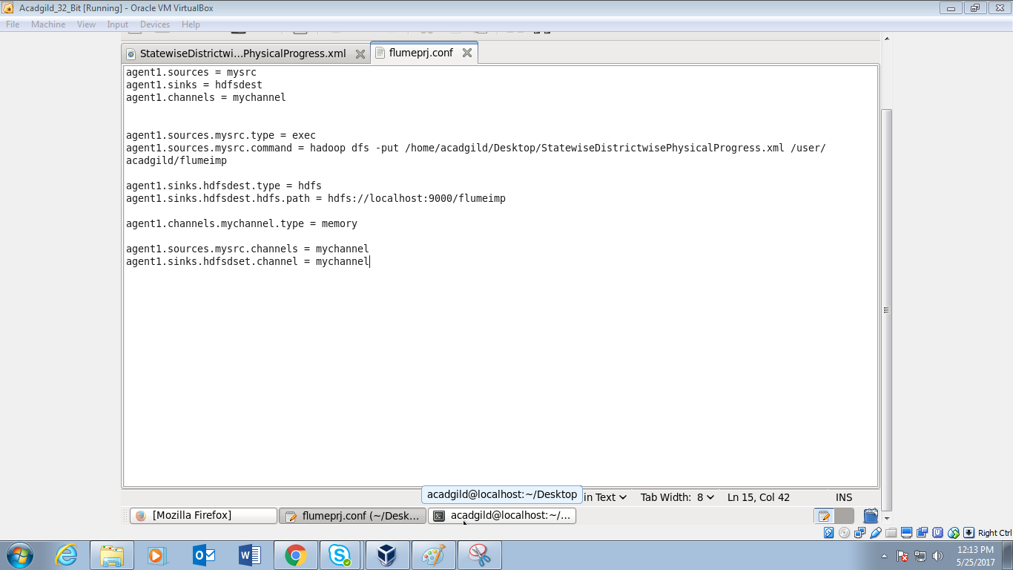

* Execution of the flume command to configure the path of above file.

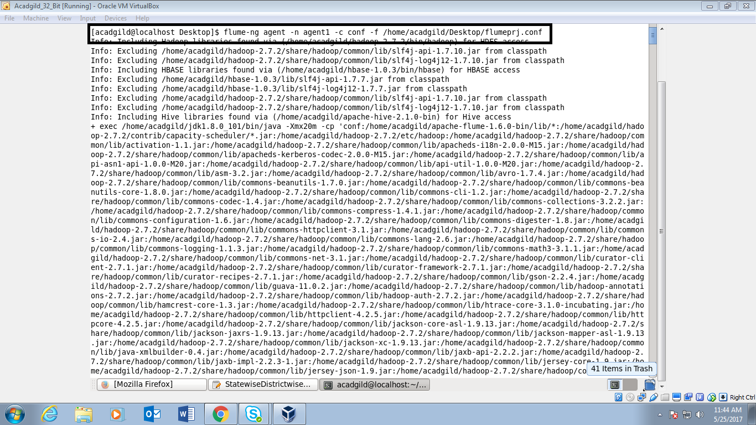

* Using –put command to copy the dataset into HDFS and its success status:

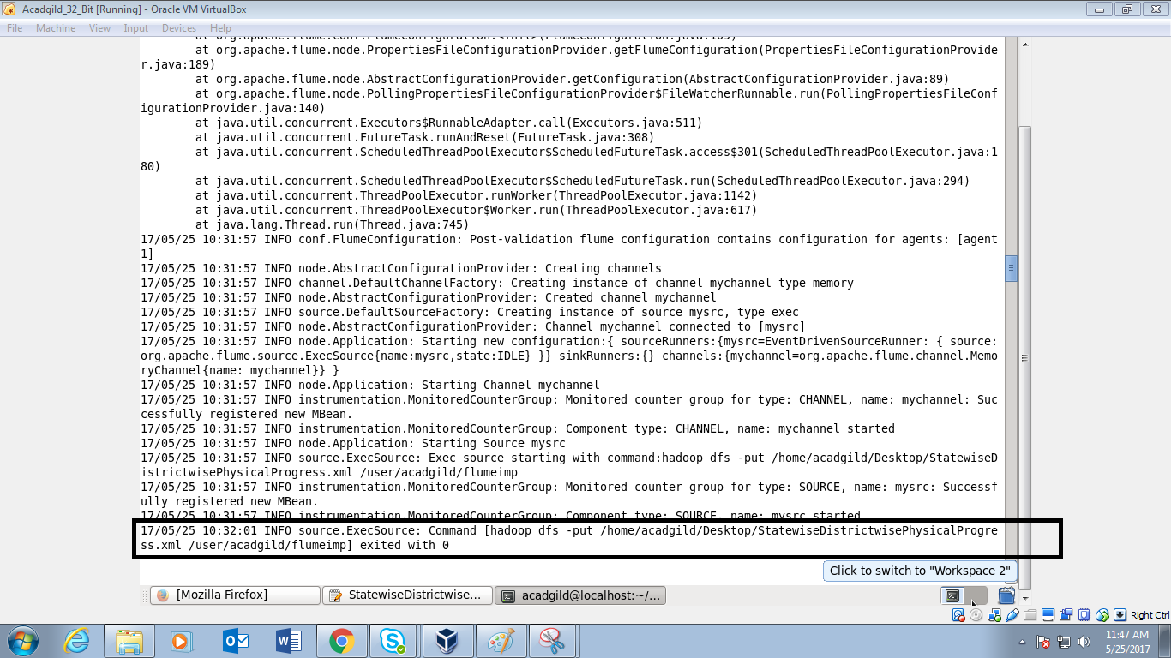

* Verifying the file presence xml flume files in HDFS:

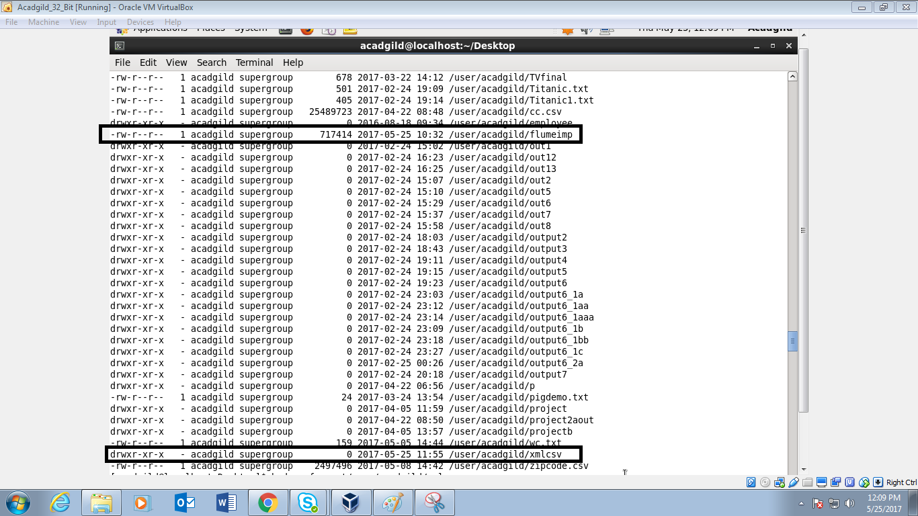

* Dataset in Xml format:

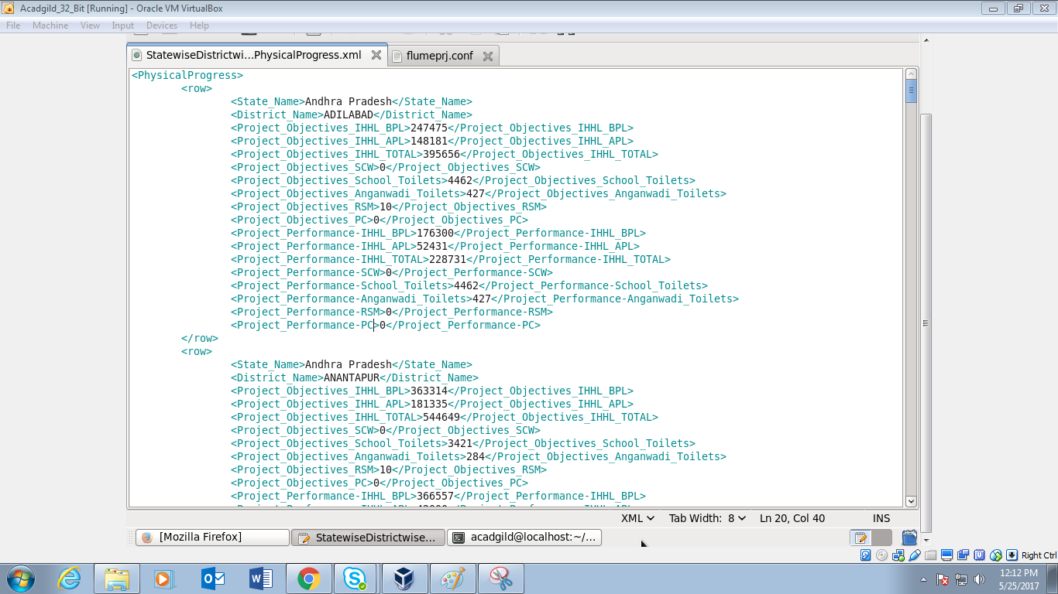

**Step-2:**

* Parsing the dataset of xml format into the csv format using pigscript:

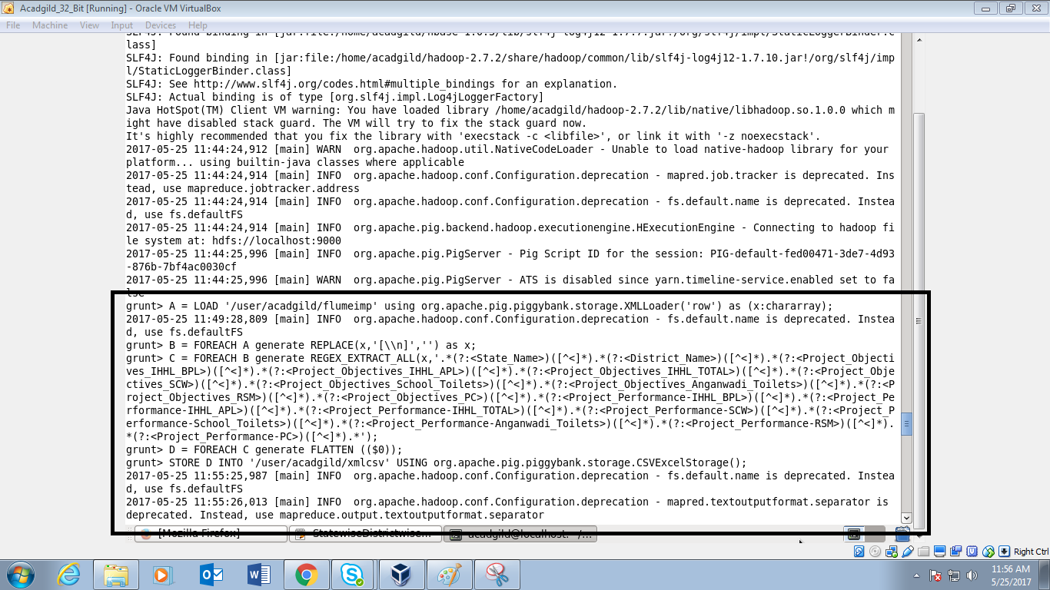

* Listing the directories present in user/acadgild:

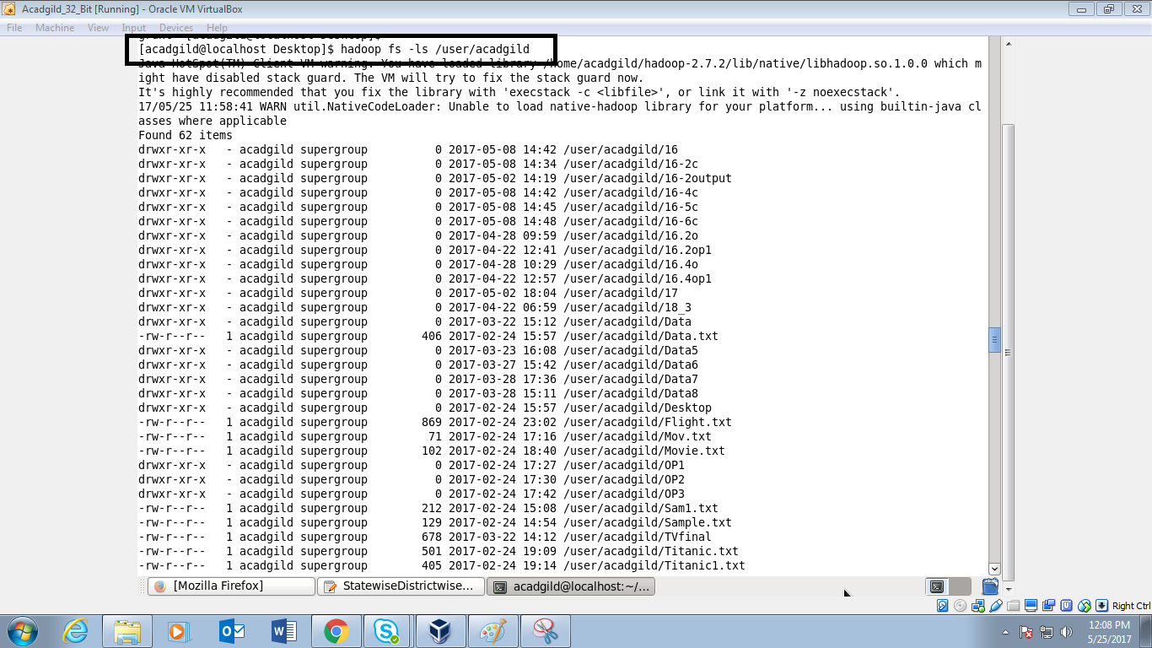

* Verifying the file flumeimp and xmlcsv in the given path:



* Listing the files inside the xmlcsv and using –cat command executing the pigscript and finally getting the output int the csv format(rows fields separated by ’,’)

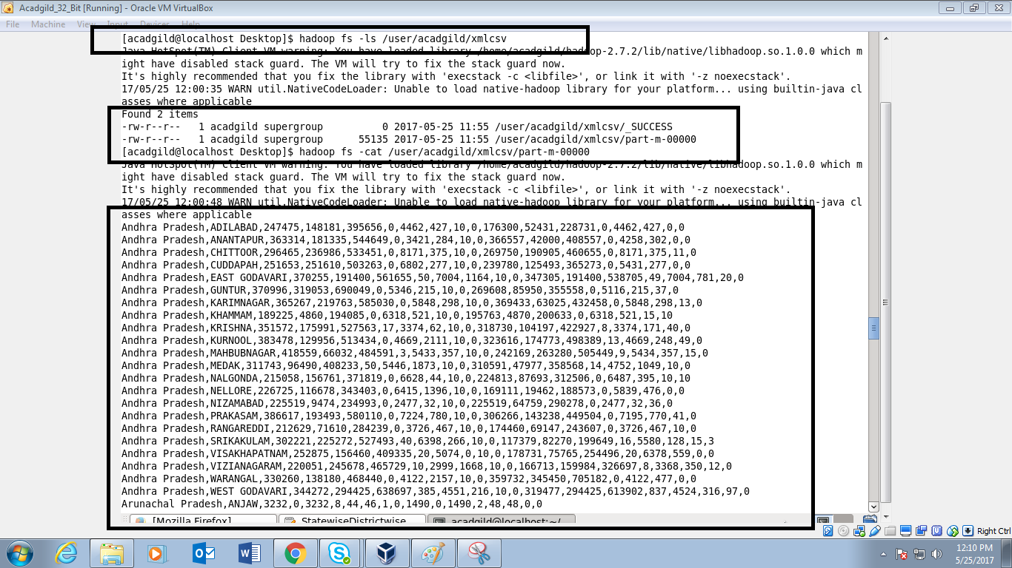

**Ques1. ) Find out the districts who achieved 100 percent objective in BPL cards Export the results to mysql using sqoop:**

* Pigscript of the below executed queries:

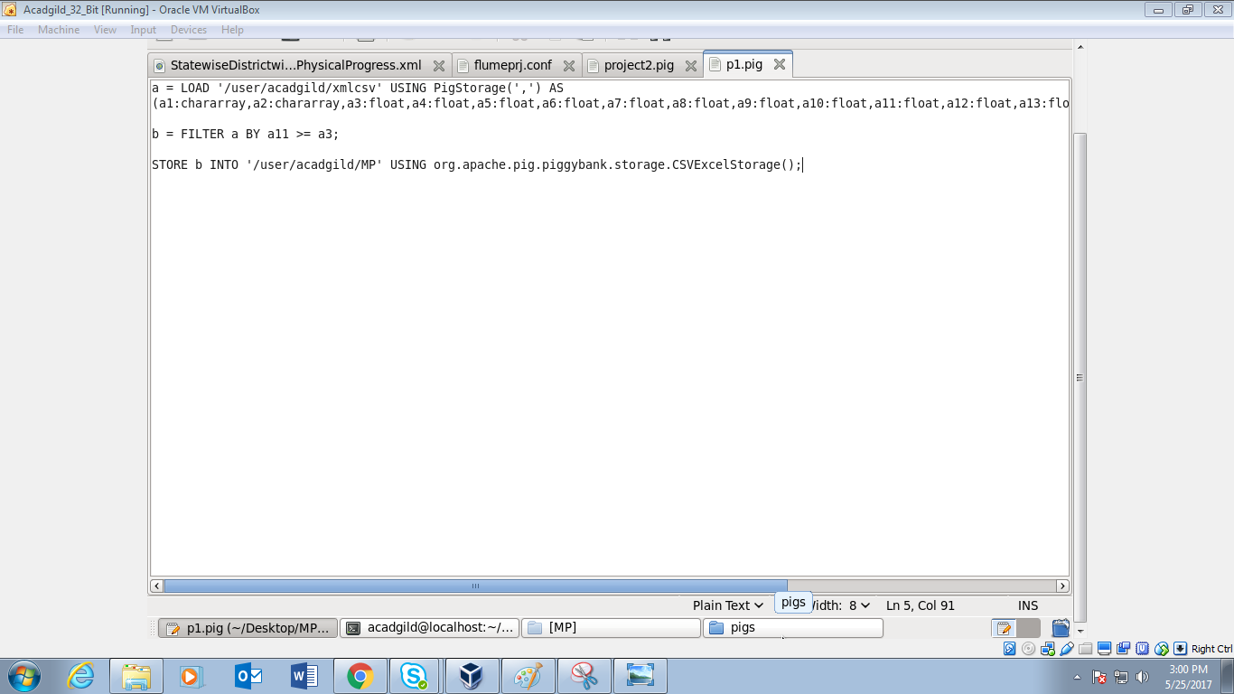

* Executing the p1.pig :

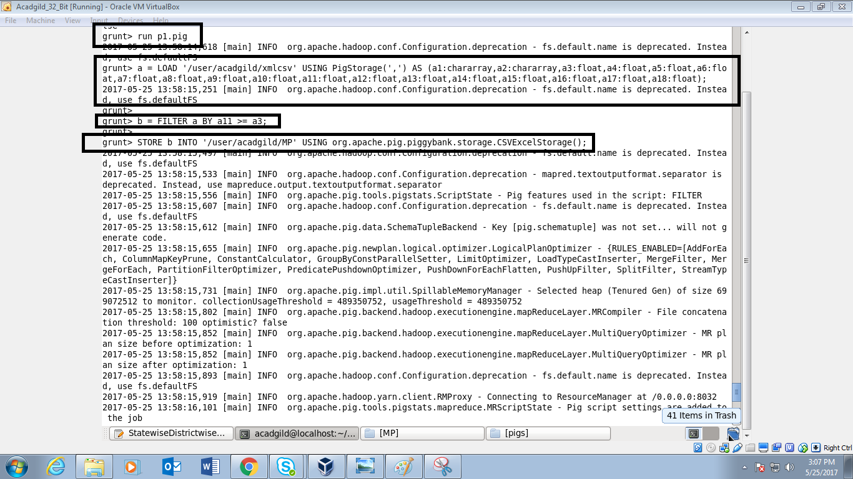

* Success status of the p1.pig where it reads the records from xmlcsv and after filtering got the result stored in MP:

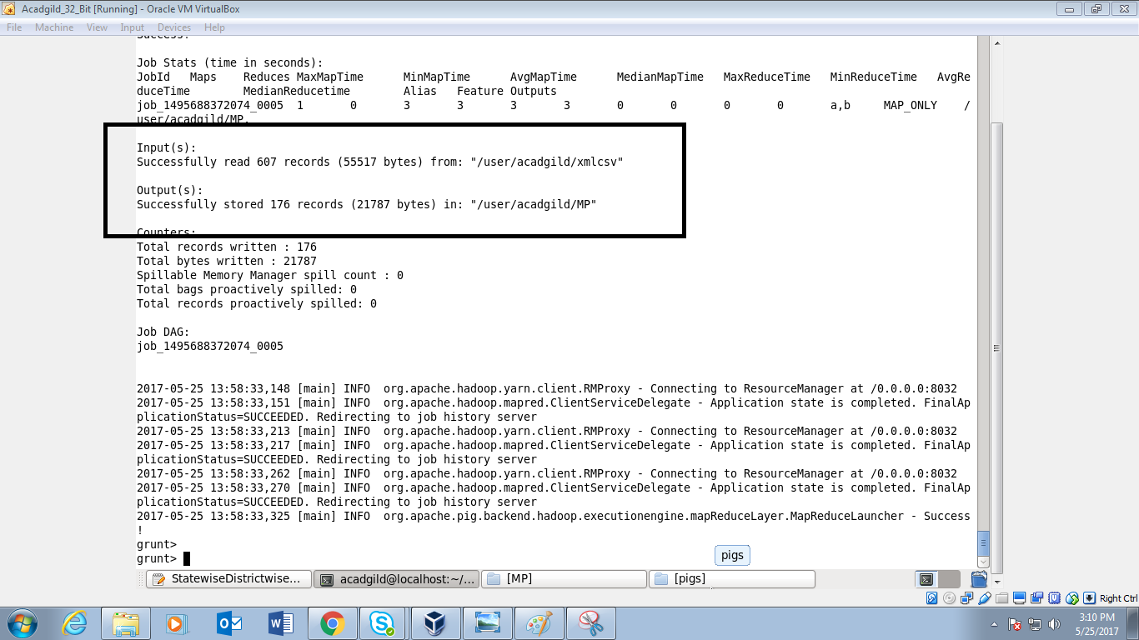

* Executing –ls on MP and thereafter –cat command to get the desired output:

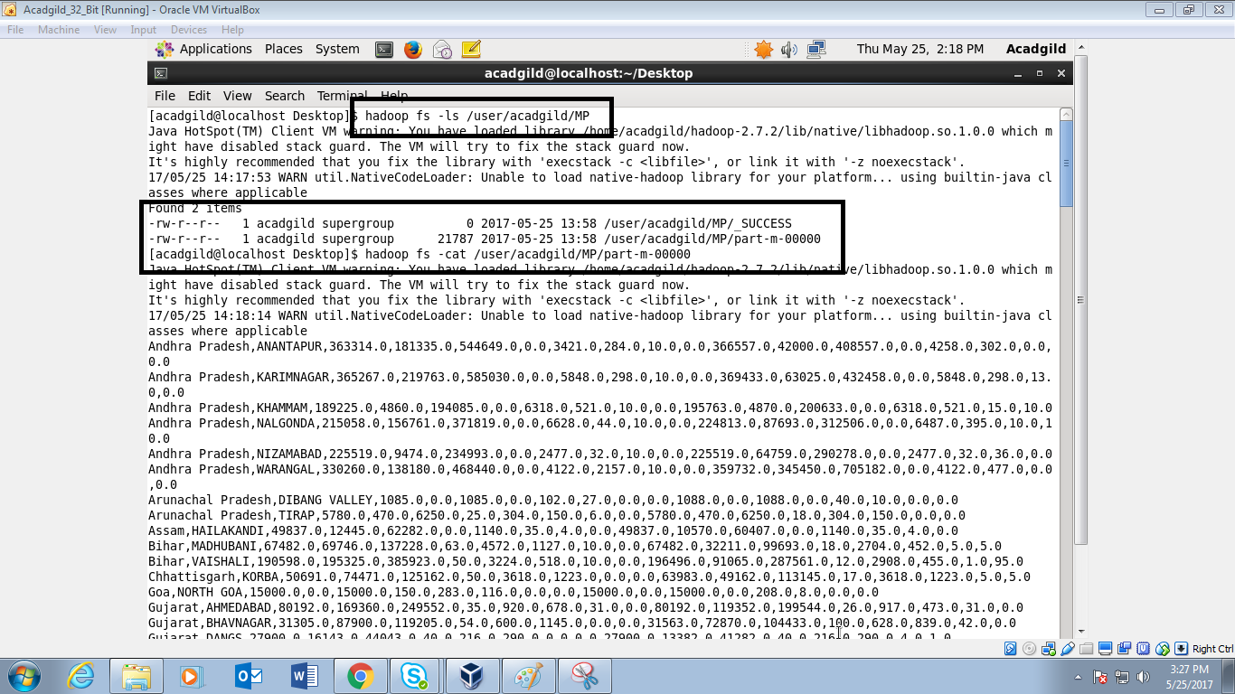

* Output continued:

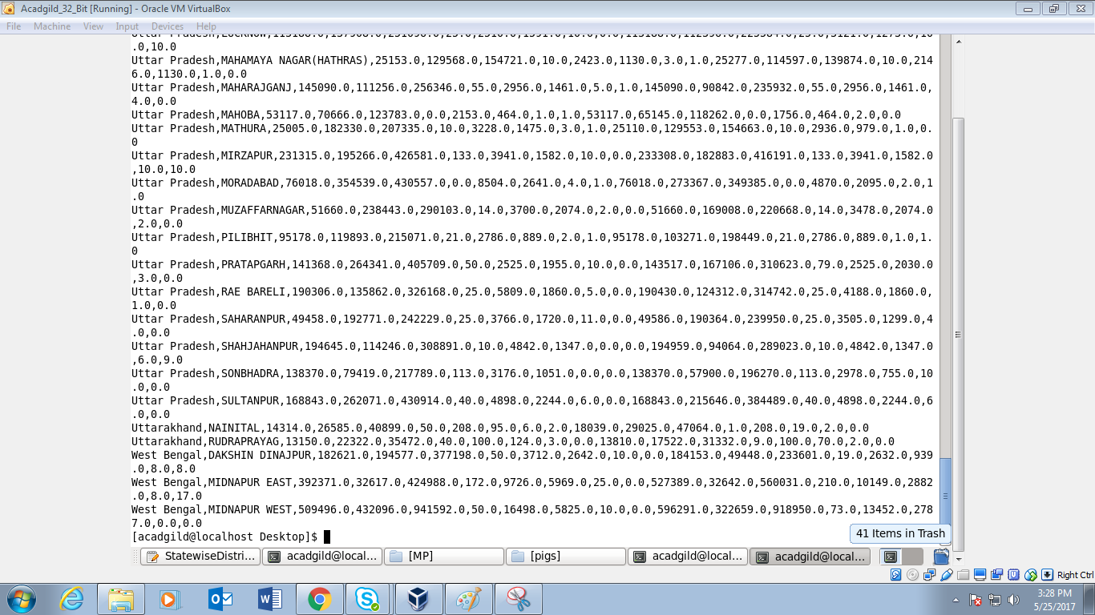

* Creating a table in mysql by the name project1:

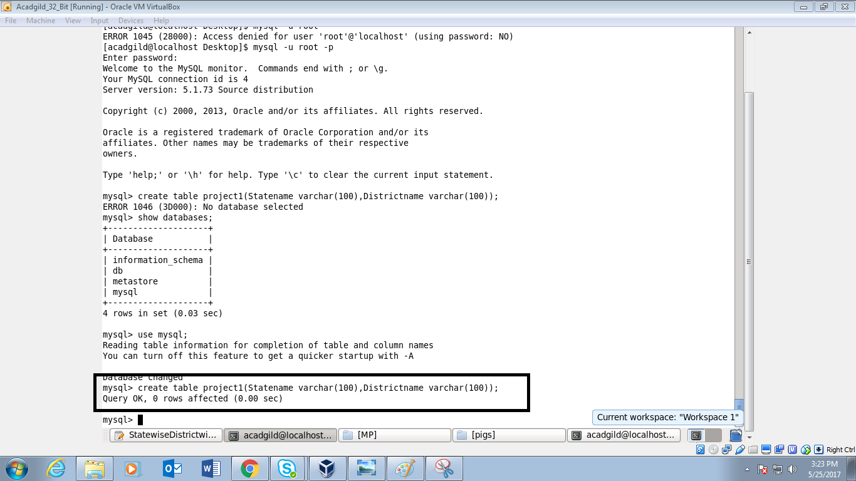

* Exporting the data from hdfs to mysql using sqoop command:

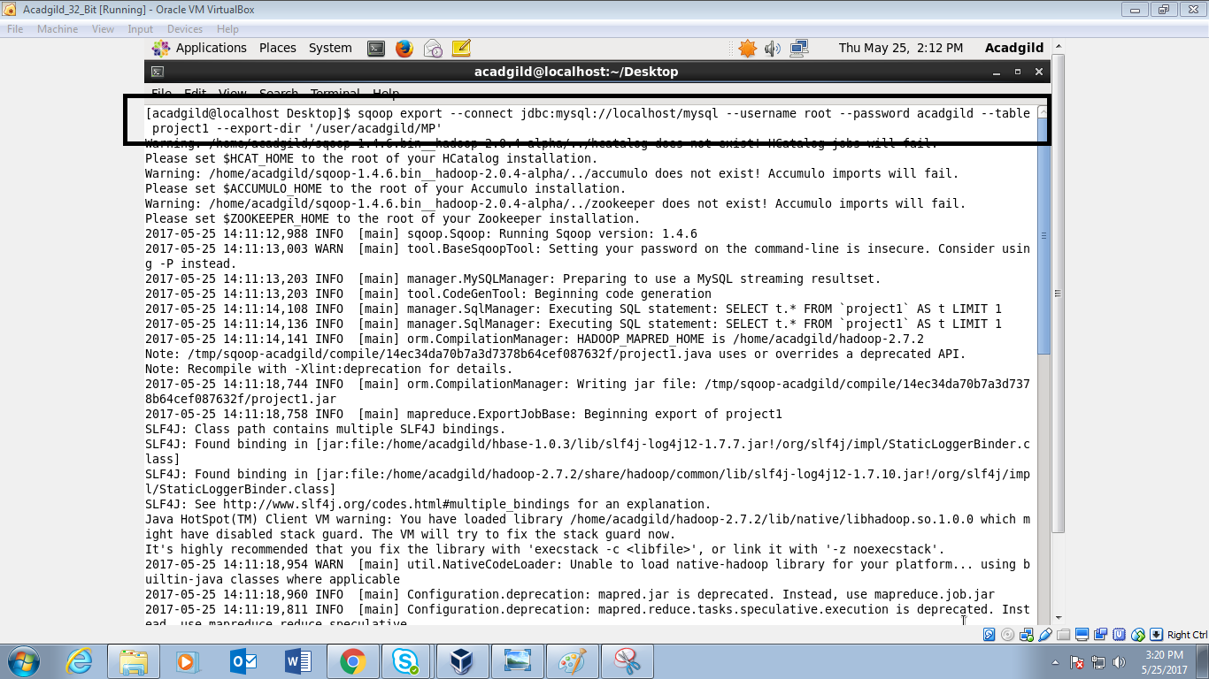

* Success status of the export command of sqoop:

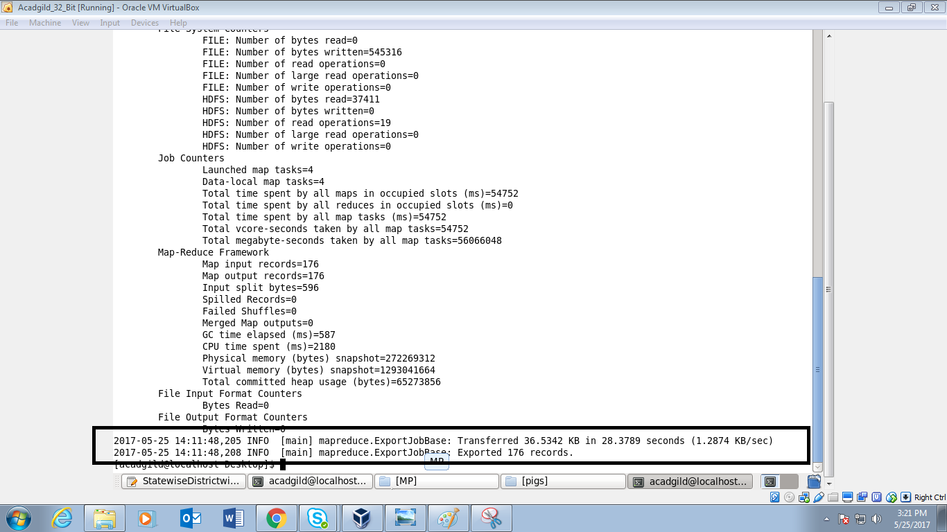

* Displaying the contents of the table project1 using select * :

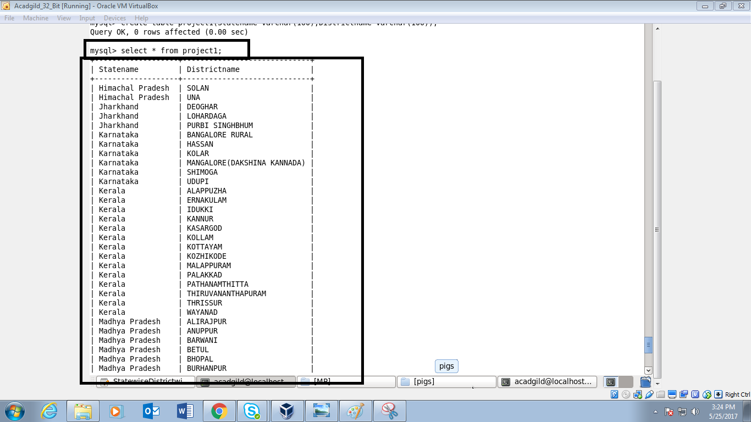

* Outpt continued:

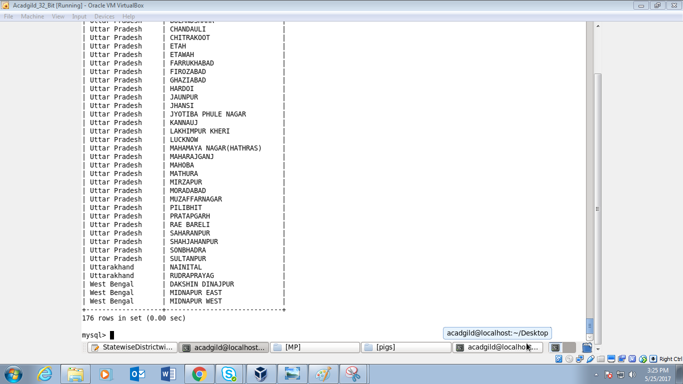

**Ques2.) Write a Pig UDF to filter the districts which have reached 80% of objectives of BPL cards. Export the results to MySQL using Sqoop.**

* UDF where the condition is given for the states who achieved more than 80% of objectives:

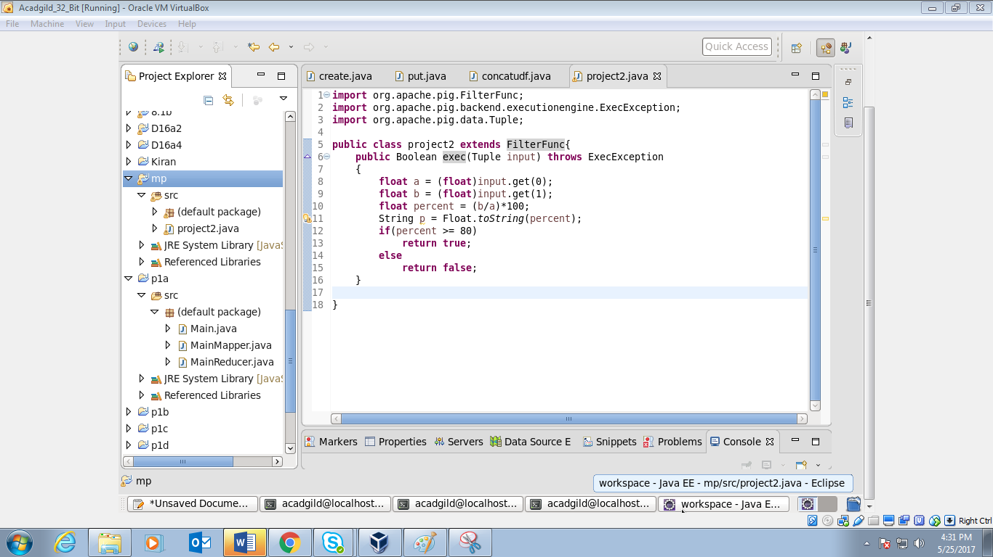

* Registering the jar as mainproject2.jar:

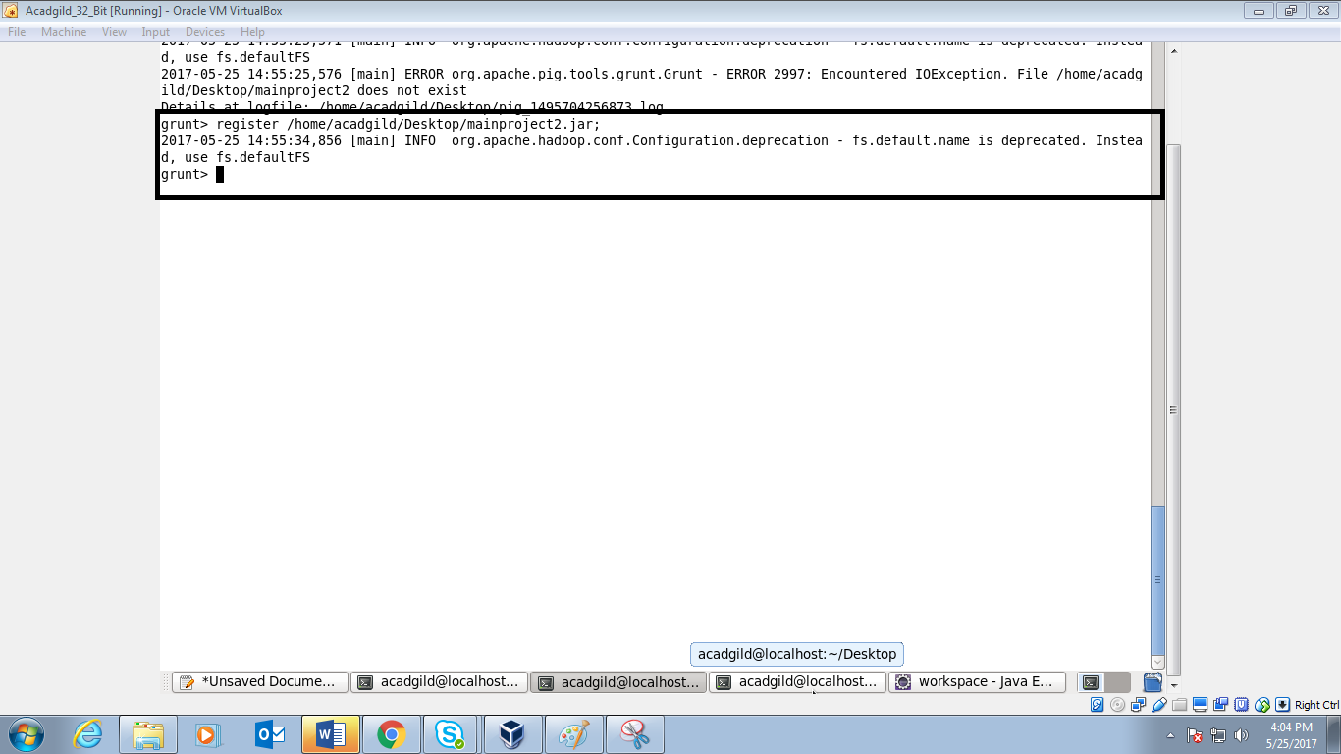

* Pigscript for the below executing queries for getting the desired output:

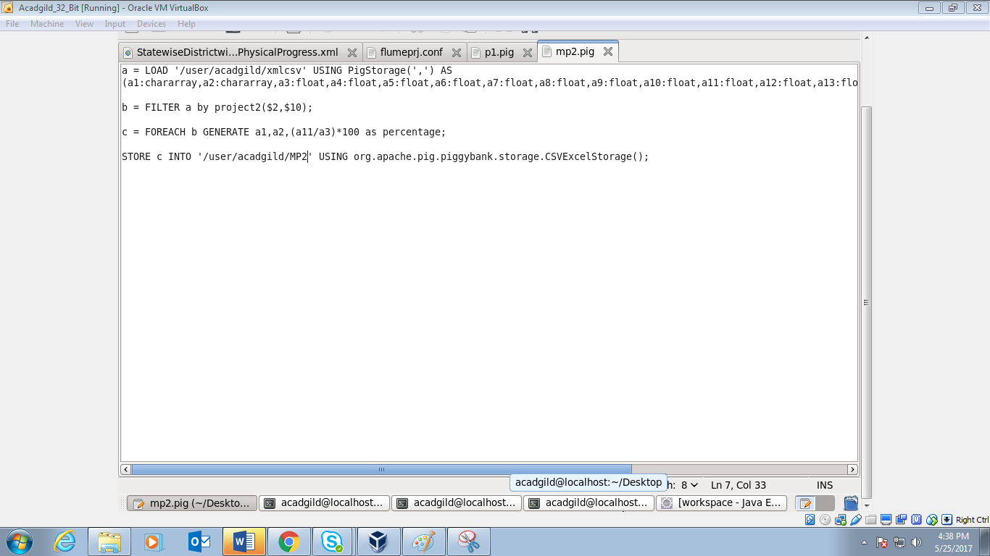

* Running the above pigscript:

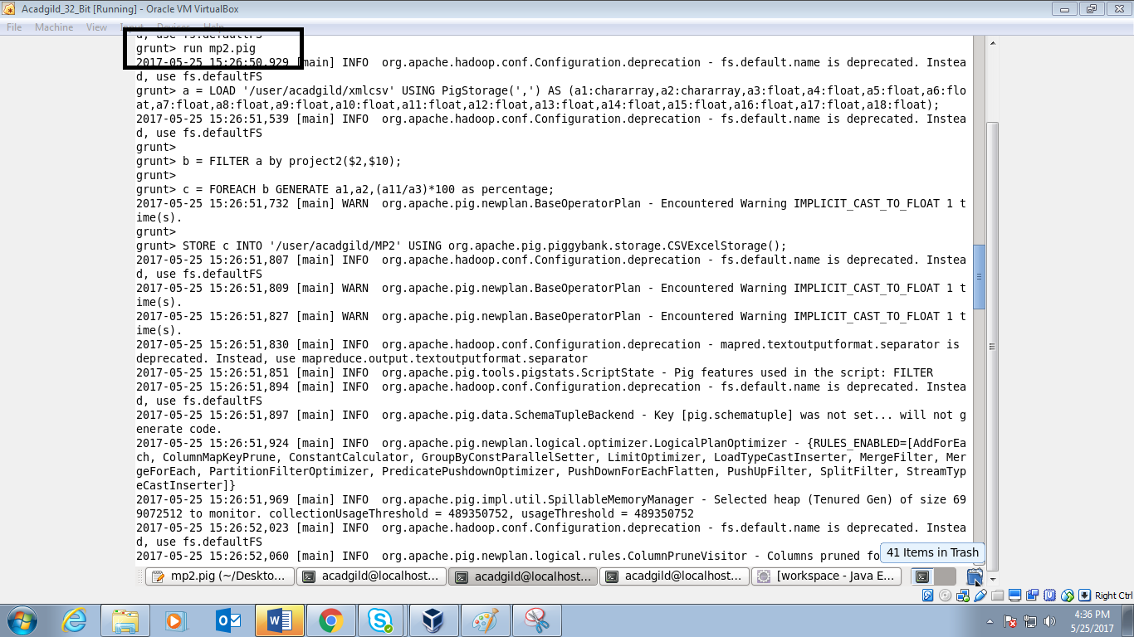

* Success status of the above executed pigscript:

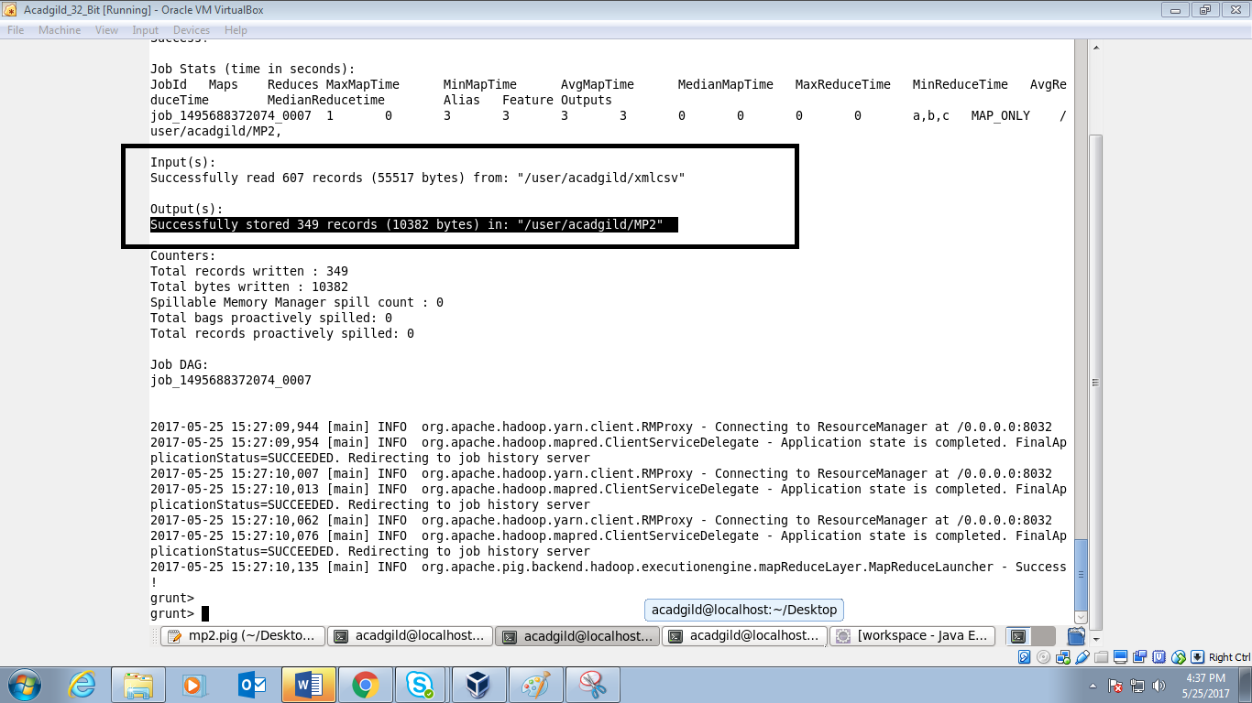

* Using the –ls command in the MP2:

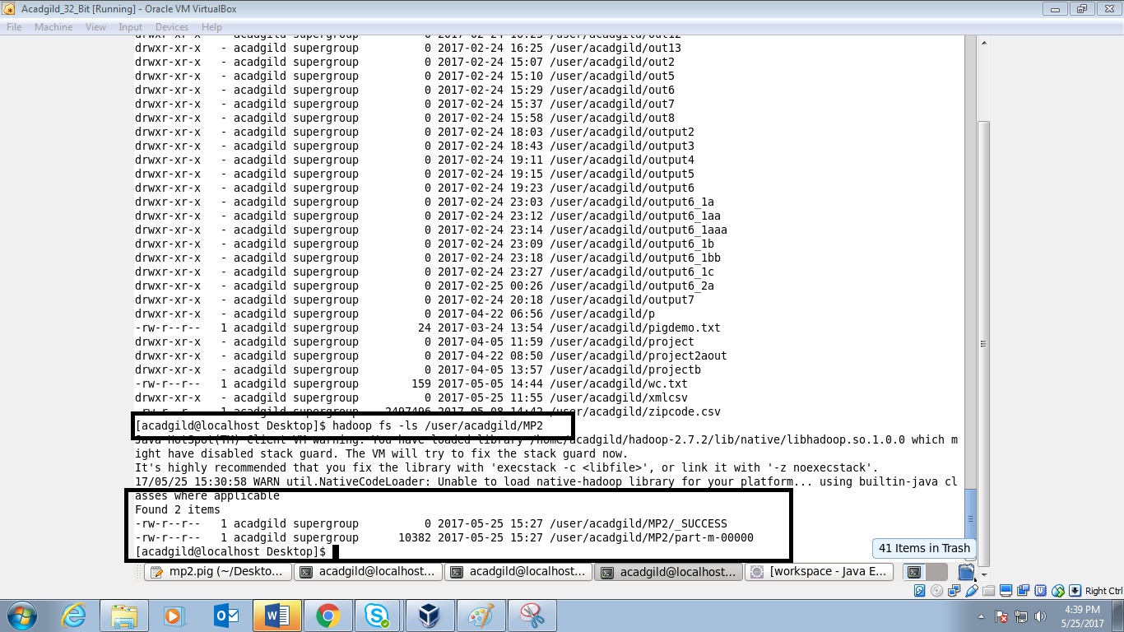

* Using –cat command obtaing the contents inside MP2:

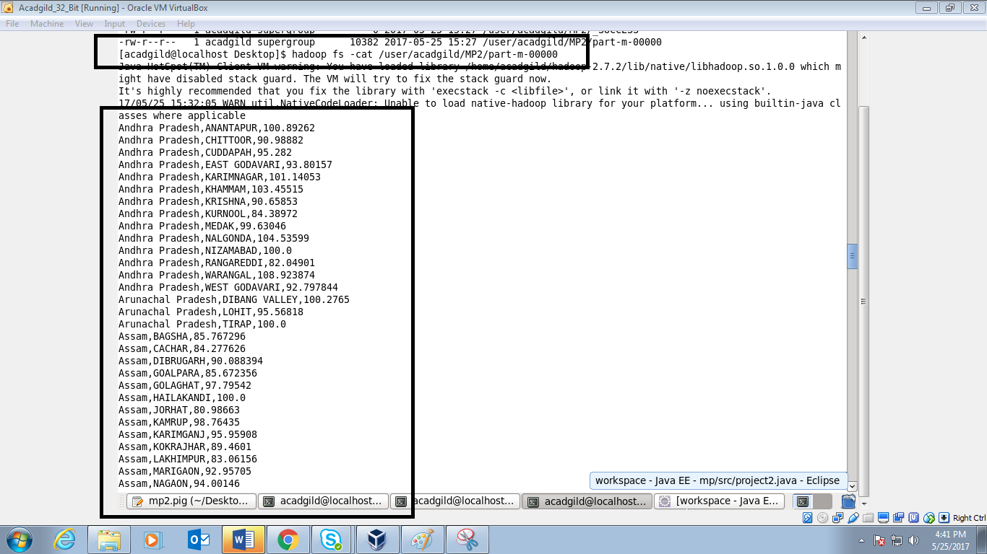

* Output continued:

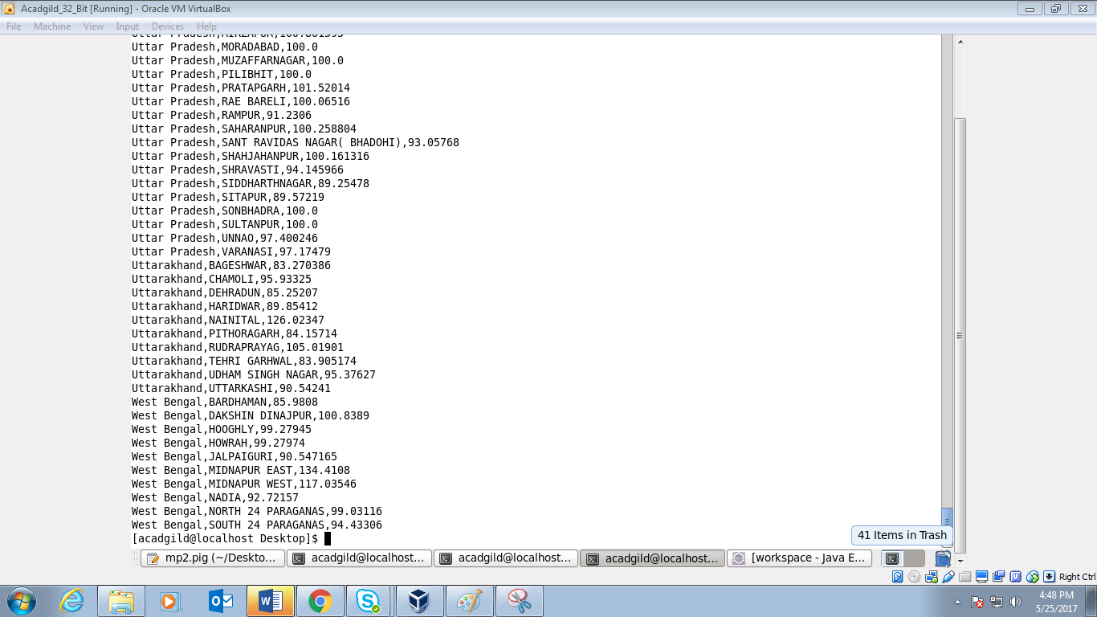

* Exporting the data from hdfs to mysql using sqoop command:

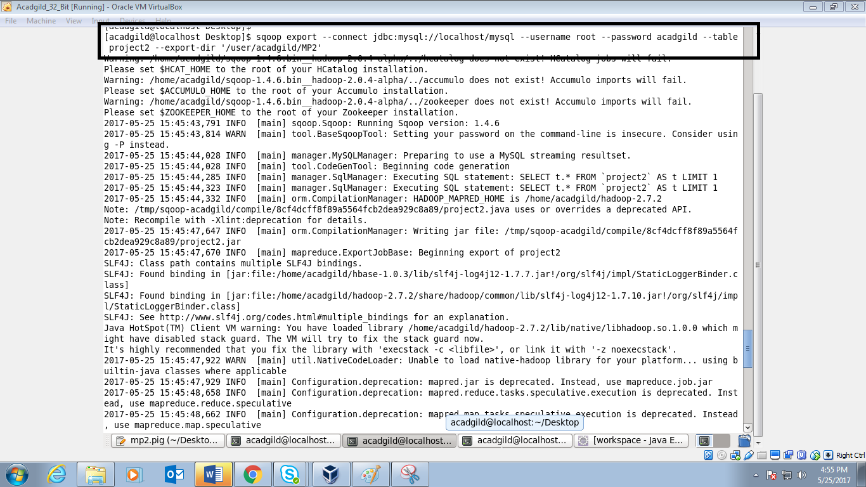

* Success status of the export command:

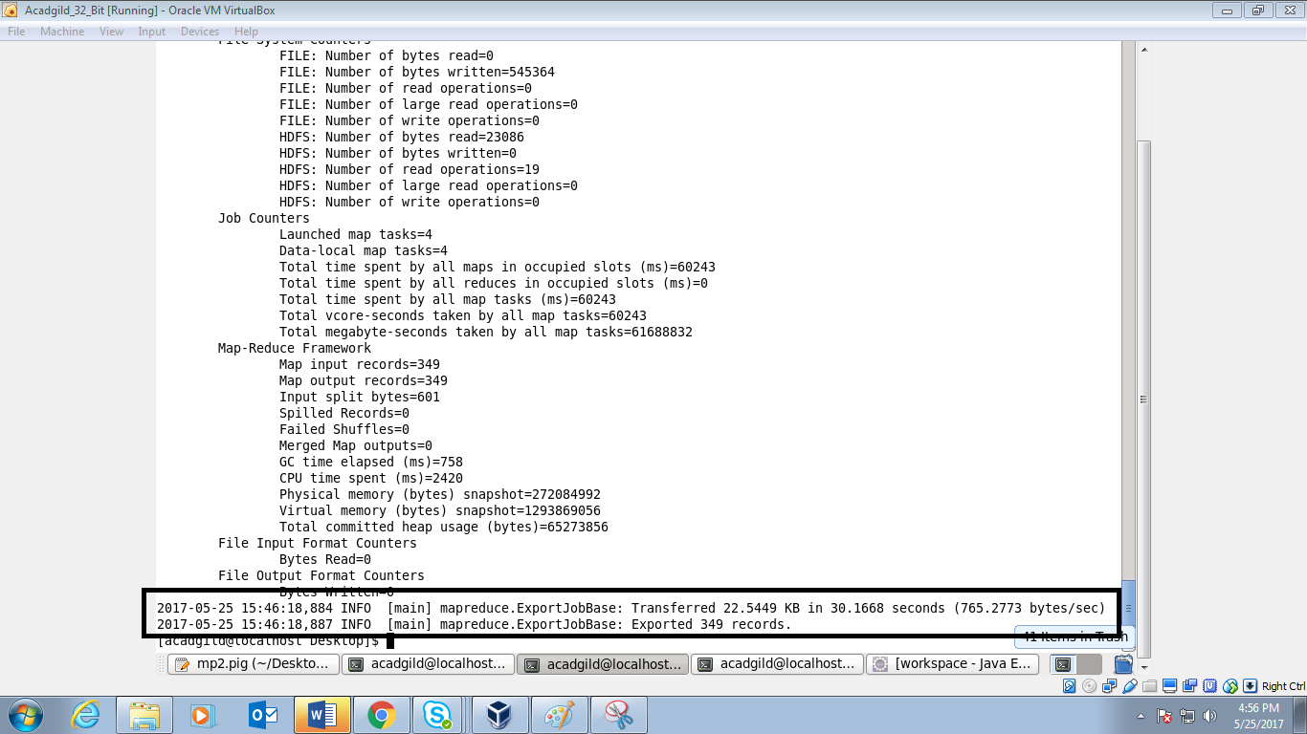

* Creating the table in mysql by the name project2 and displaying the output using select *:

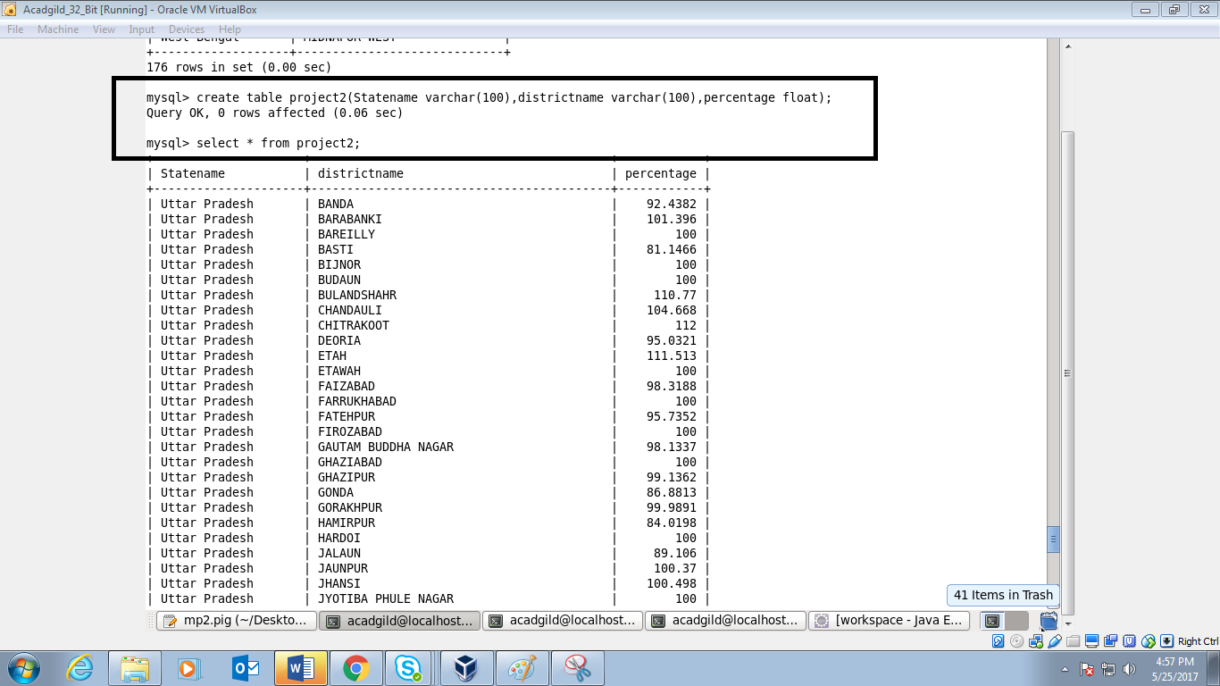

* Output continued:

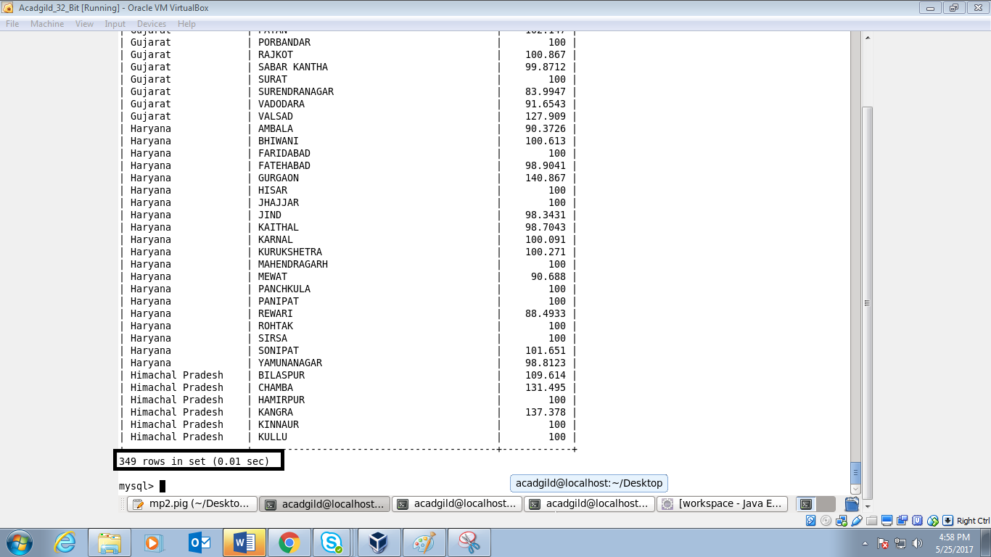

* **SHELL SCRIPTING METHOD:**

Below is the shell script for the major project:

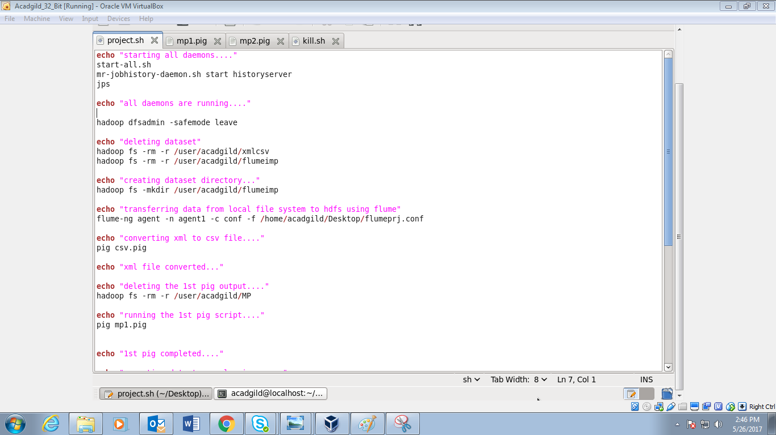

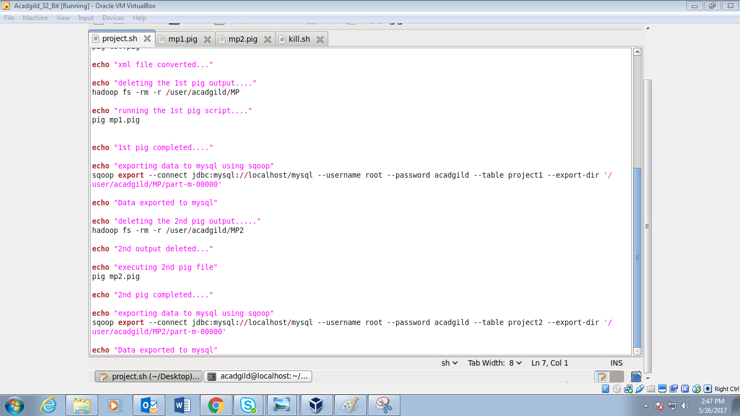

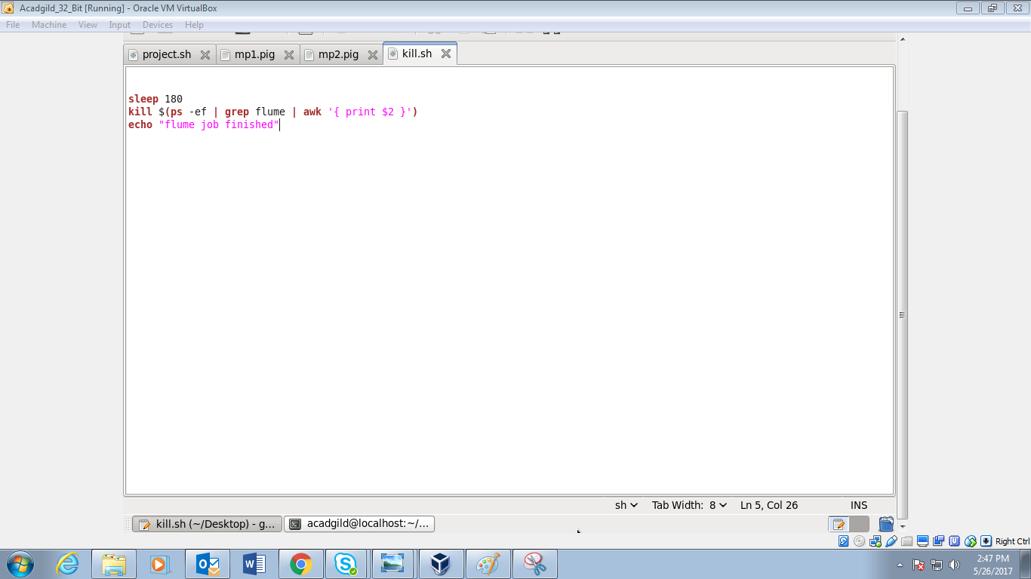

* Using the following command for starting the shellscript:

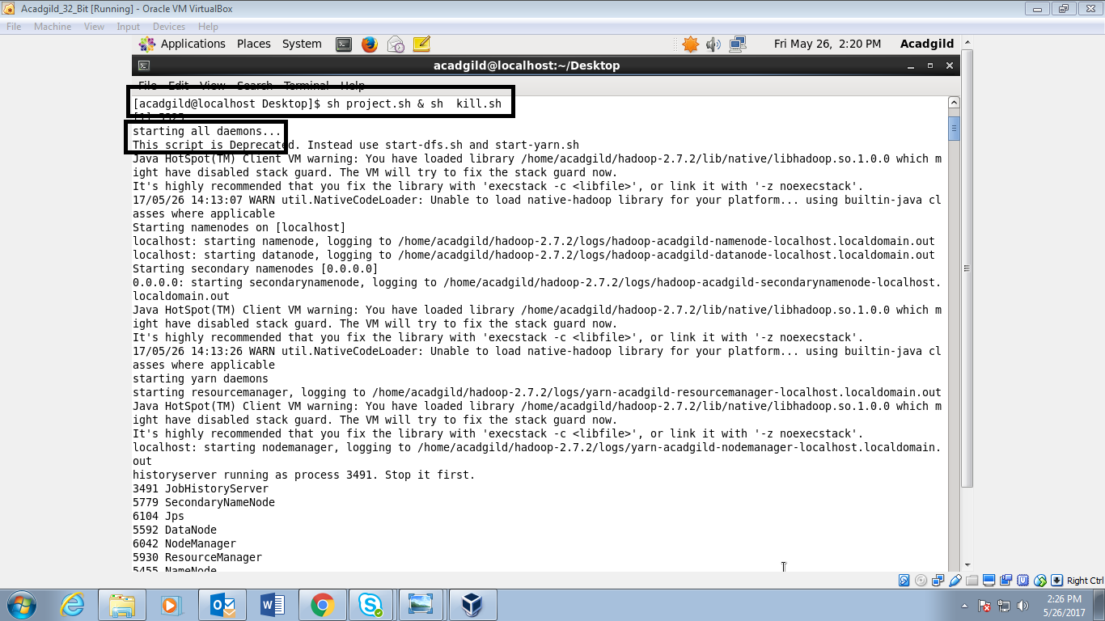

* Jps command to see which all daemons are running:

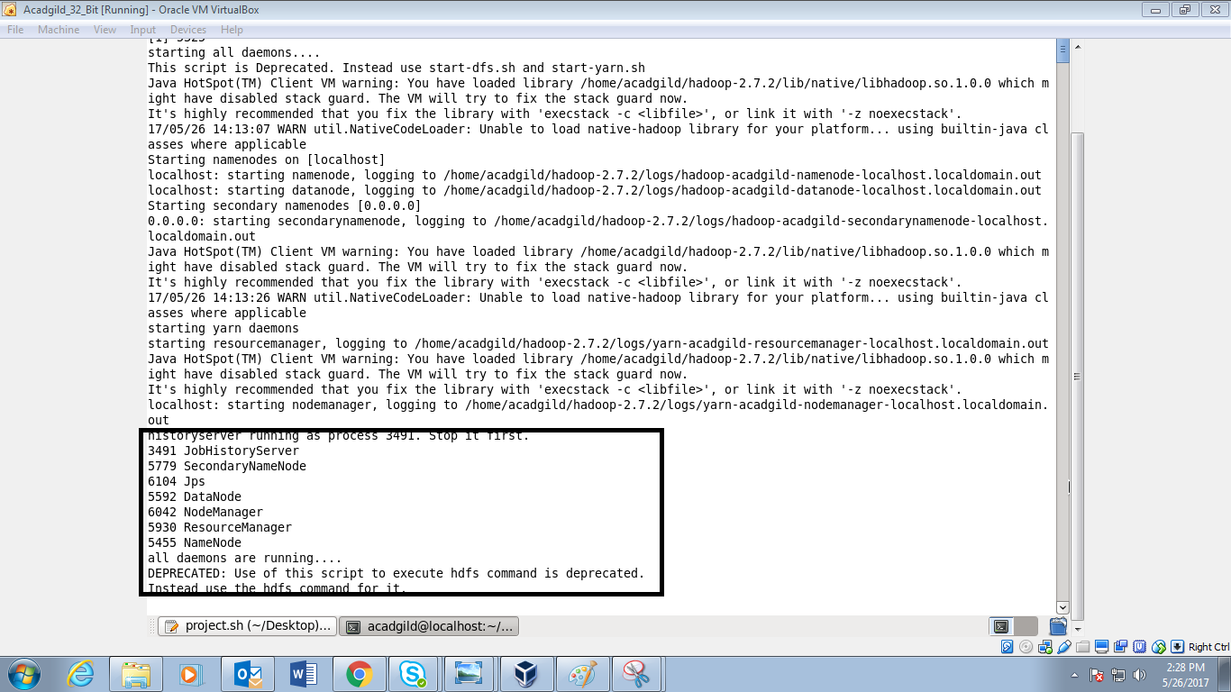

* Success status of deleting xmlcsv and flumeimp:

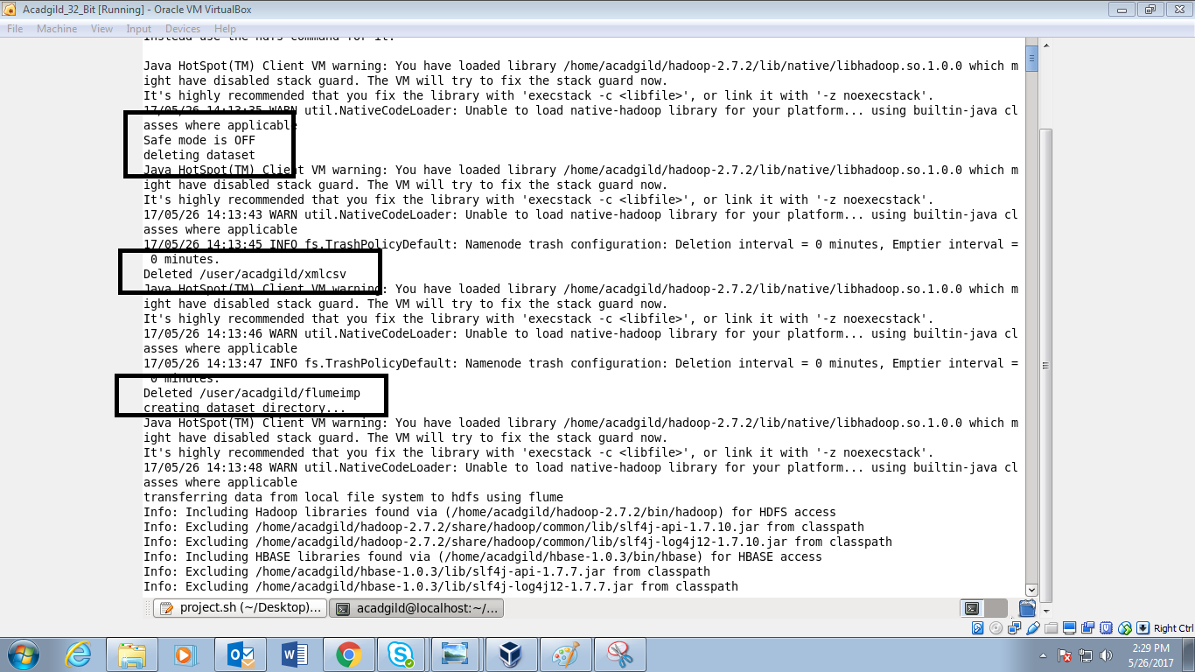

* Running status:

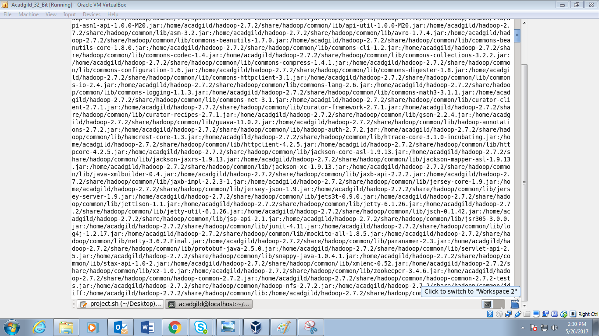

* Success status :

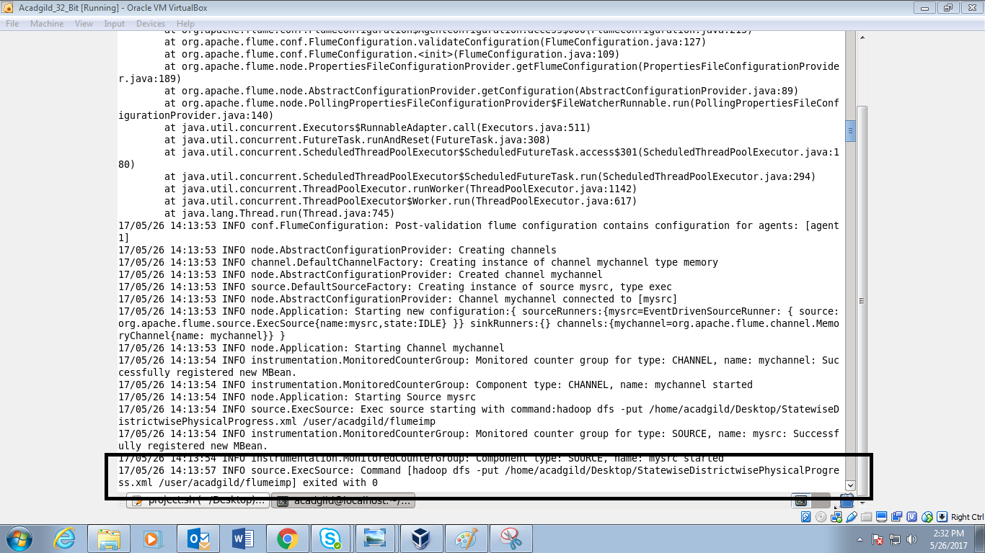

* Conveting xml to csv:

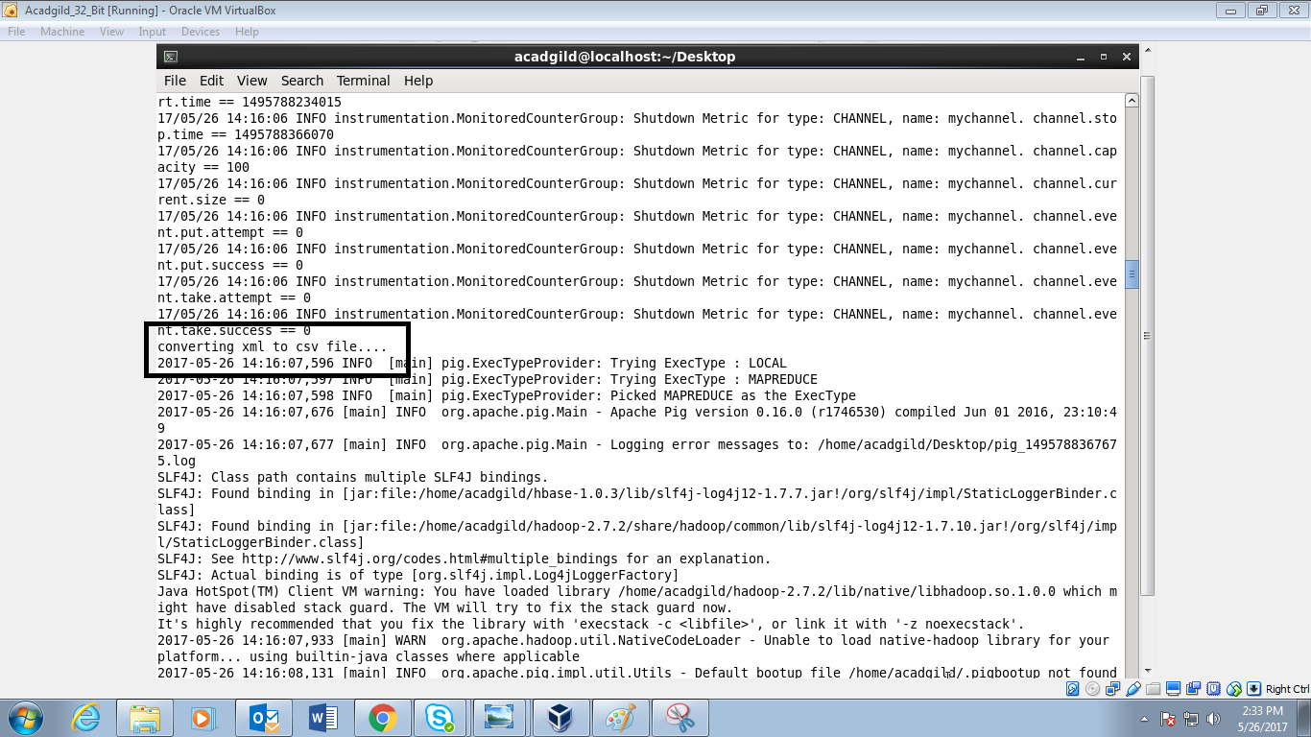

* Success status of conversion of dataset from xml to csv:

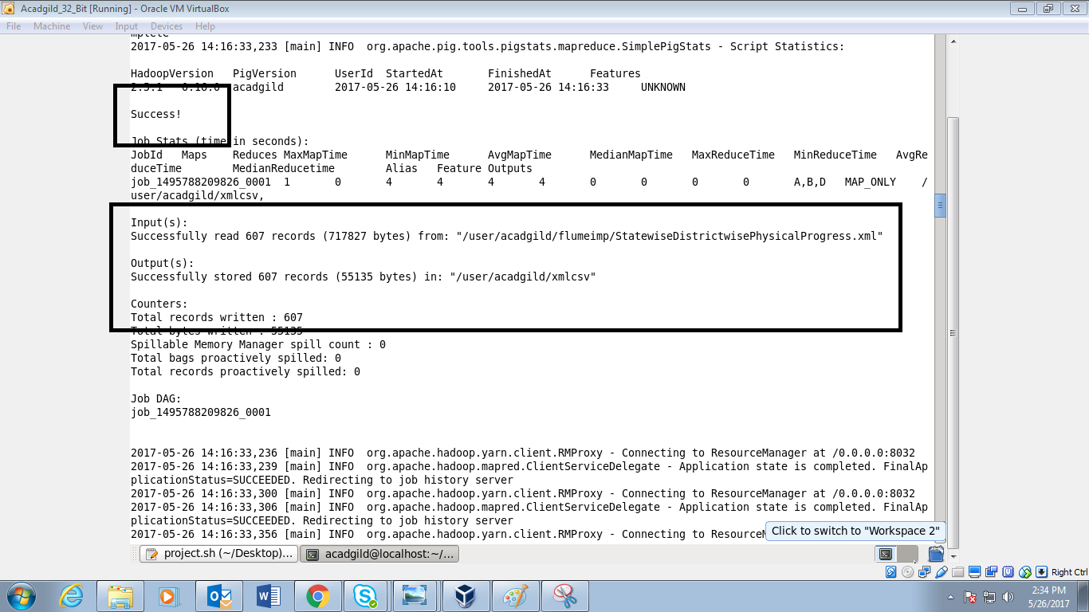

* Xml converted to csv and running status of 1st pigscript:

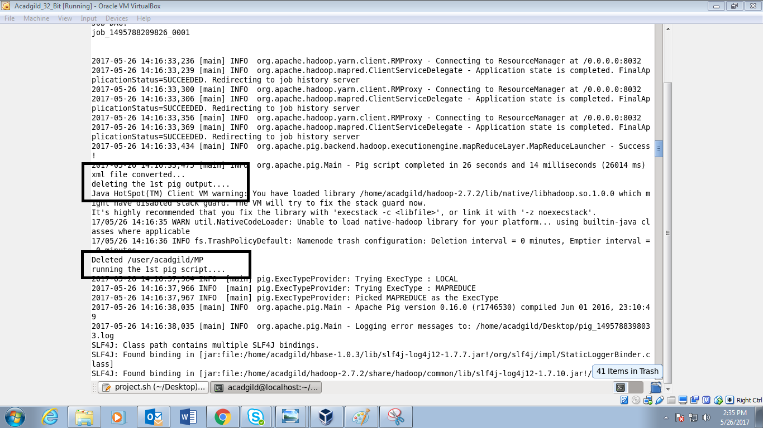

* Success status of 1st pig script:

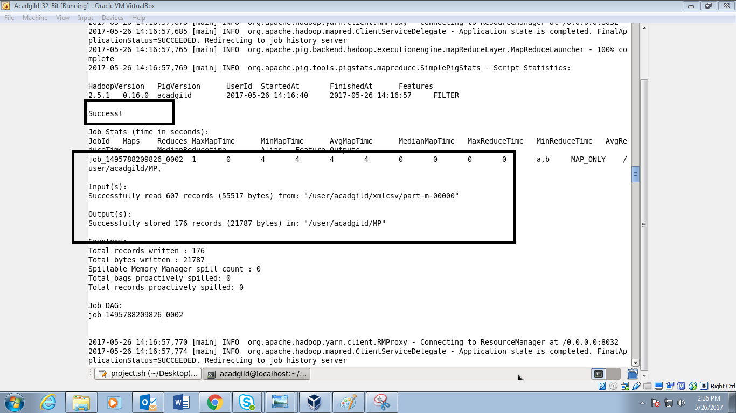

* Exporting the data to mysql using sqoop:

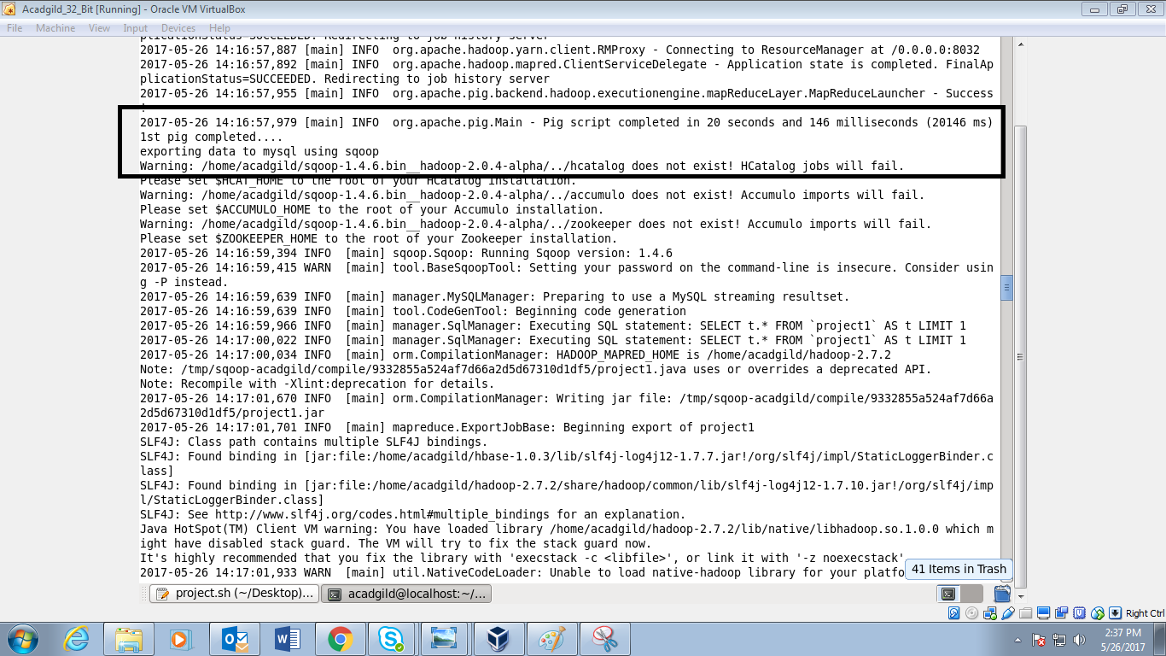

* Success status of exporting the data to mysql and now deleting the 2nd pig output:

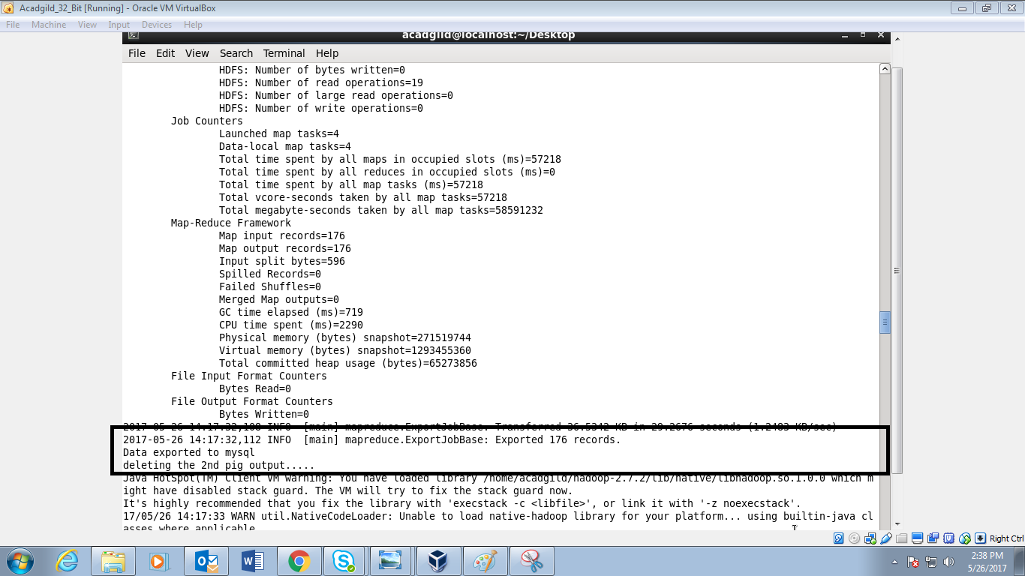

* Success status of deletion and successfully the data is stored in MP2:

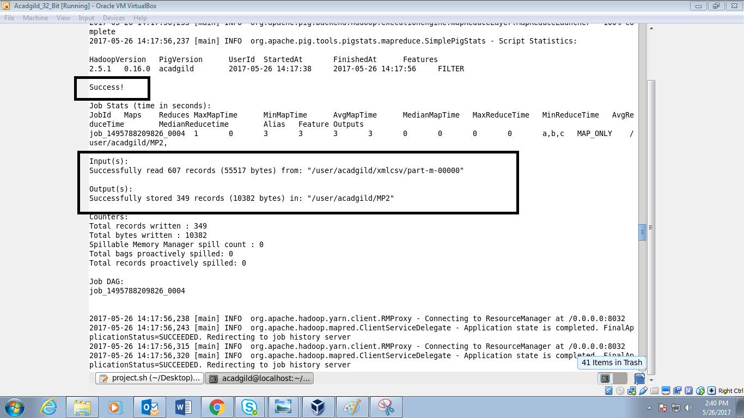

* Success status of 2nd pig :

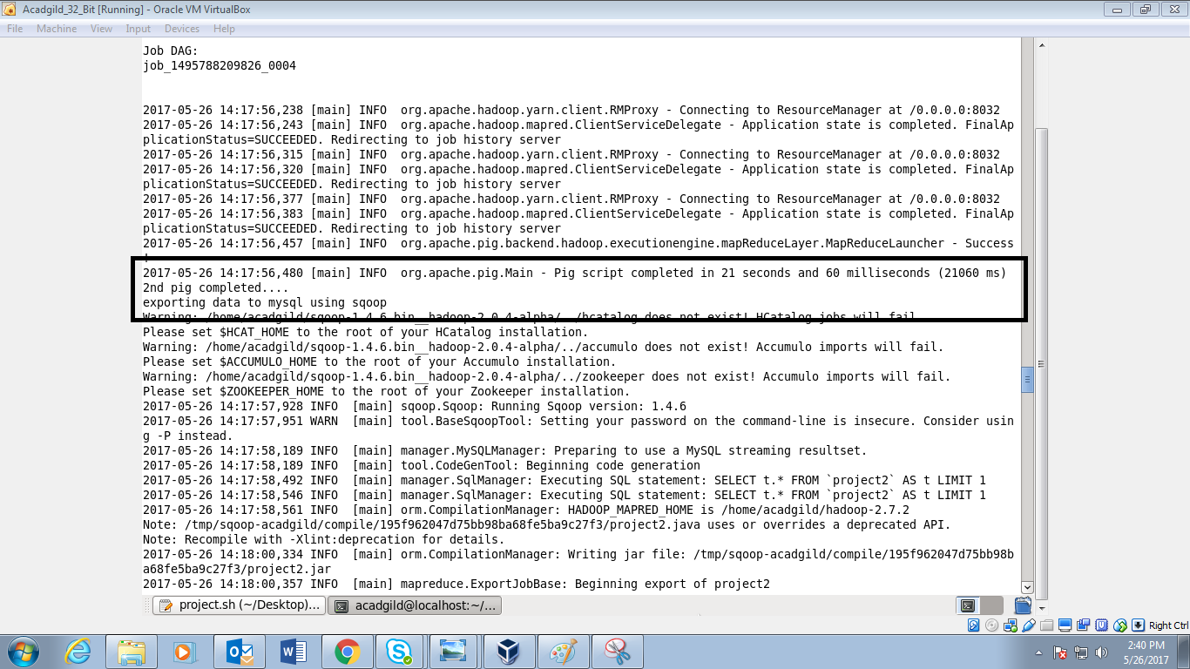

* Success status of data exported to mysql:

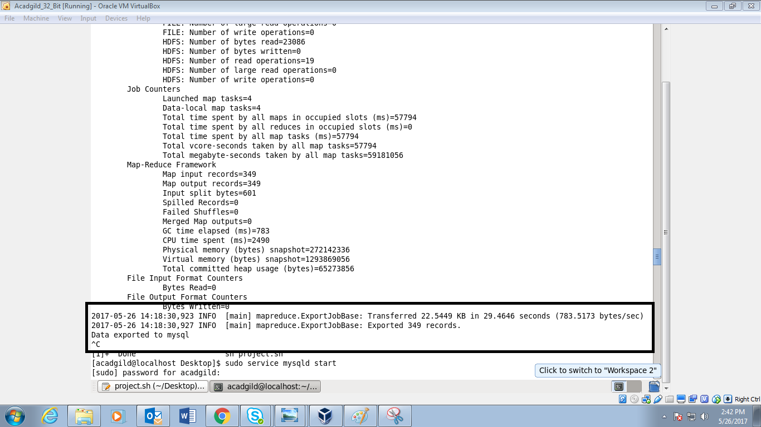

* Starting the mysql and changing database to mysql and displaying table project1 details::

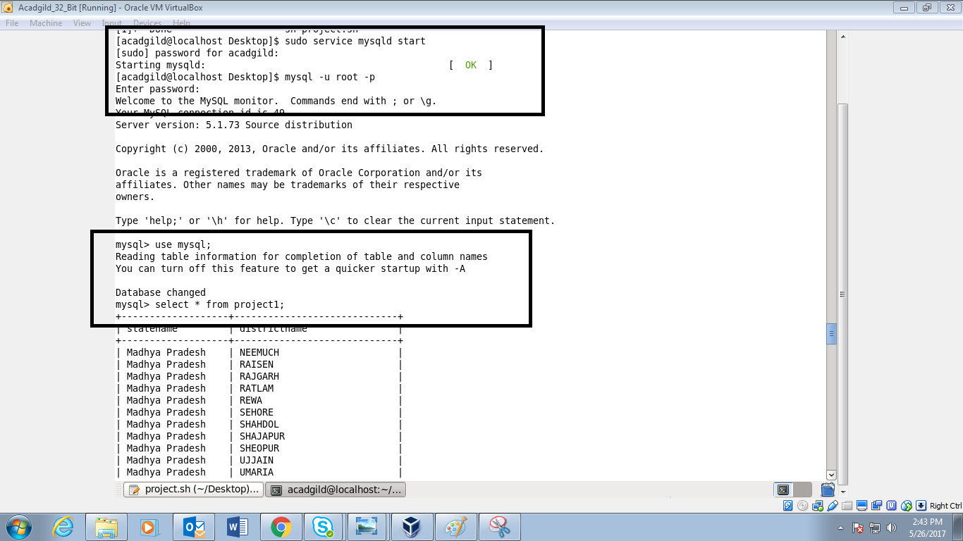

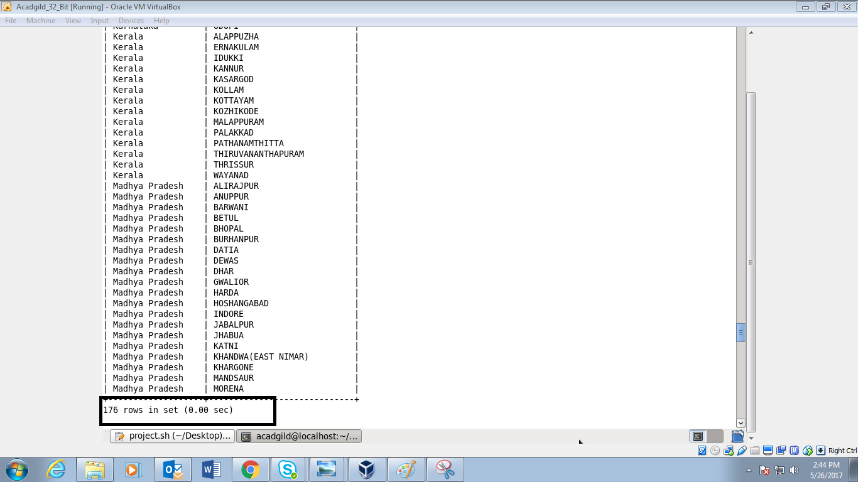

* Displaying the details in project2 table:

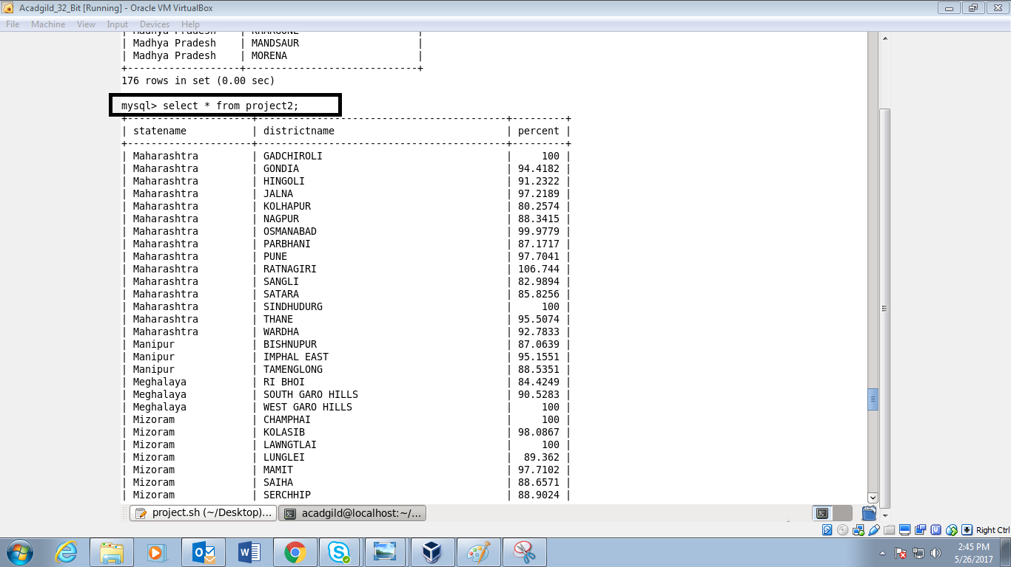

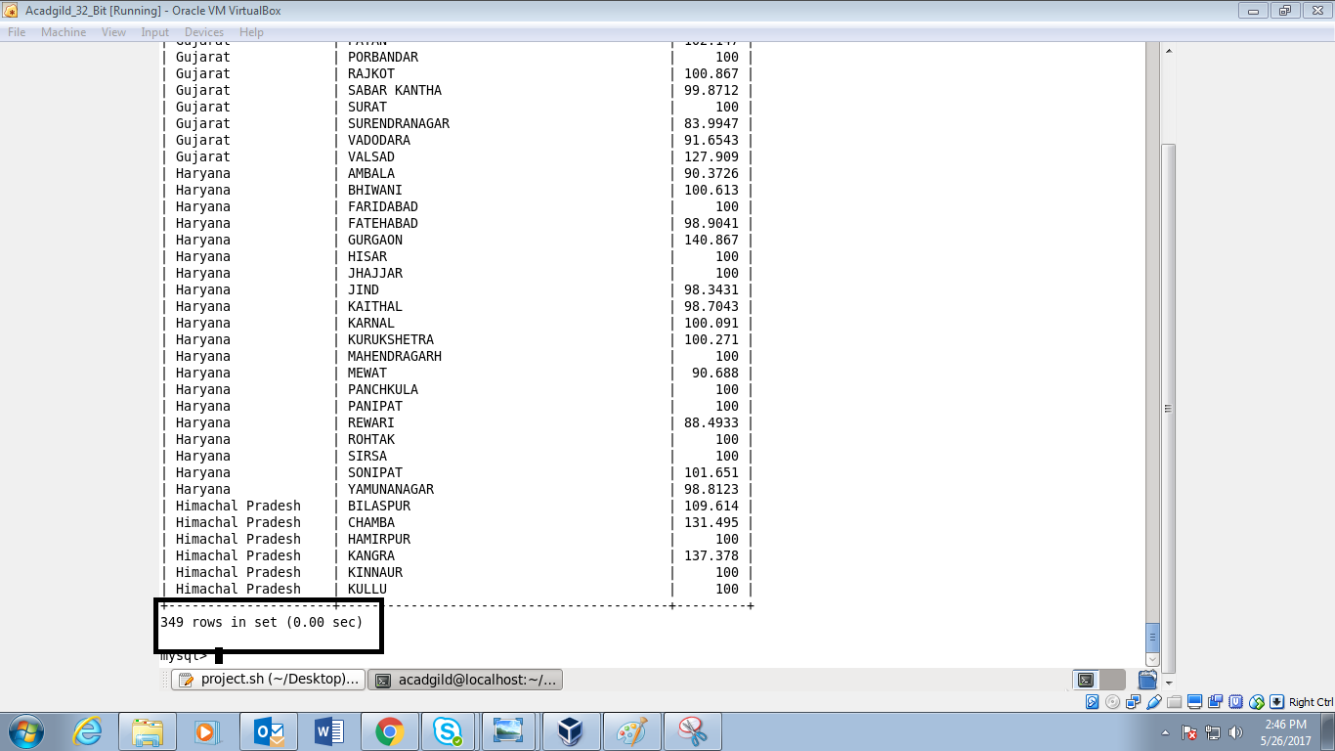

* Pigscripts used to parse xml into csv :

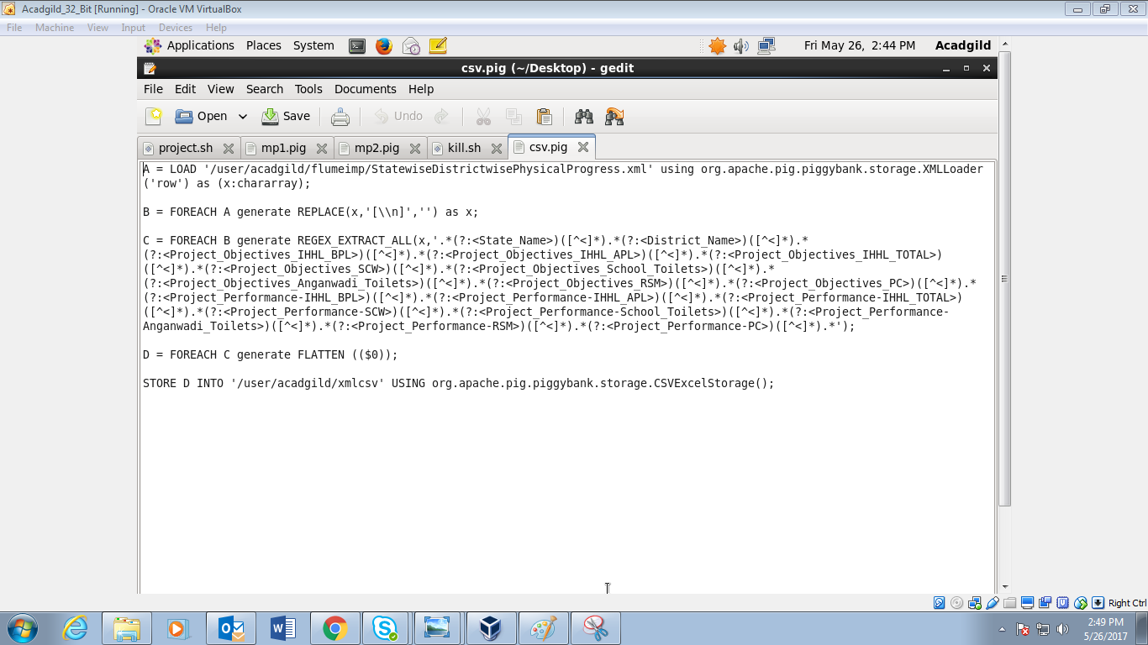

* Pigscript used for mp1:

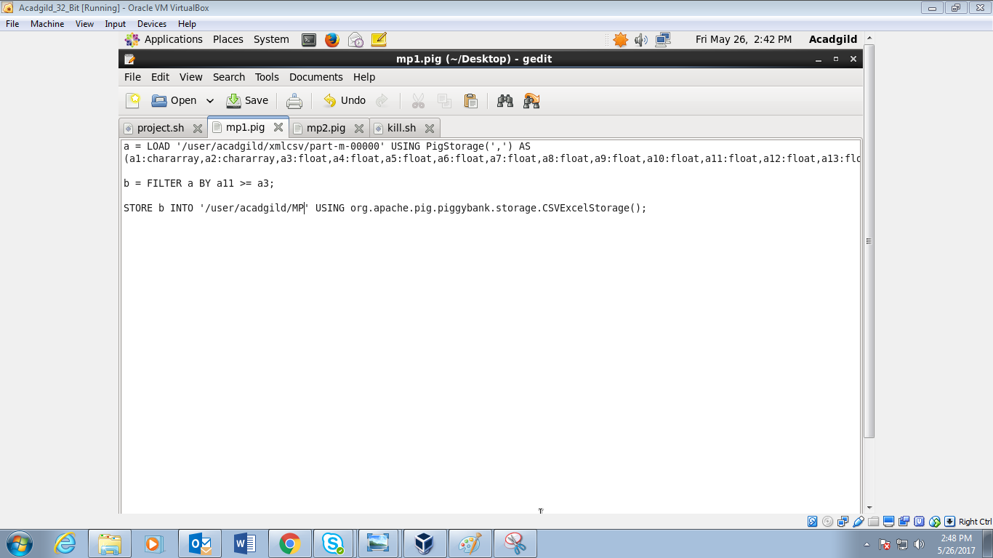

* Pigscript used in MP2:

